Article Original
Post Operative Infection in ENT Cancerology: about 138 Observations
Infection post opératoire en cancérologie orl : à propos de 138 observations
Moustapha Ndiaye¹, Ciré Ndiaye¹, Ngor Ndour¹, Malick Ndiaye², Abdou Sy², Mame Sanou Diouf³, Amadou Thiam¹, Houra Ahmed¹, El Hadji Abdou Aziz Sylla¹, Birame Loum¹, Baye Karim Diallo¹, Louise Fortes Deguenonvo¹, Richard Deguenonvo¹, Evelyne Siga Diom³, Abdourahmane Tall¹, Issa Cheikh Ndiaye¹, Raymond Diouf¹
- Cheikh Anta Diop University, Dakar, Senegal  - Université de Thies, Thies, Senegal  - Université Assane Seck de Ziguinchor, Ziguinchor, Senegal  Auteur correspondant : Moustapha Ndiaye  Adresse e-mail : moustapha0905@gmail.com  Boite postale : 9183  Keywords: infection, postoperative, operating site, ENT cancer, carcinology  Mots-clés : infection, post opératoire, site opératoire, cancer ORL, carcinologie | ABSTRACT
 | Background. Any surgical procedure involves an infectious risk due to the rupture of the barrier constituted by the skin or the mucous membranes. Through this study, we will assess the epidemiological, bacteriological and therapeutic profile of postoperative infections. Patients and methods. This is a 03-year retrospective study on a series of 138 patients with ENT cancer who had been extirpated. The circumstances of occurrence of post-operative infections have been studied. Results. The frequency of post-operative infection was 23.9%. Among the 44 alcohol-smoking patients, 12 had presented a post-operative infection (p = 0.593). One patient had been treated with preoperative radiochemotherapy and had not developed postoperative infection. The tumor size among the infected population was T2 (18.9%), T3 (22.5%), T4 (51.1%); p = 0.048 and the types of closure with flaps represented 17.9% (p = 0.001). Six class 1 Altemeier patients had developed post-operative infection as well as 27 class 2; (p = 0.346). The incidence of infection in patients with a tracheostomy tube was 27.7%. The most common germs were Pseudomonas aeruginosa (16 cases), Enterobacter spp (4 cases), Staphylococcus aureus (3 cases). After adaptation to the antibiogram, the most used molecule was ciprofloxacin (21 cases). Conclusion. The occurrence of post-operative infection was strongly attributable to the use of a closure flap, hence the need to observe strict hygiene for these patients who should benefit from it.
 | RÉSUMÉ
 | Introduction. Toute intervention chirurgicale comporte un risque infectieux du fait de la rupture de la barrière que constituent la peau ou les muqueuses. A travers cette étude, nous allons évaluer le profil épidémiologique, bactériologique et thérapeutique des infections post opératoires. Patients et méthode. Il s’agit d’une étude rétrospective sur 03 ans sur une série de 138 patients porteurs d’un cancer de la sphère ORL ayant été extirpé. Les circonstances de survenue des cas d’infections post opératoires ont été étudiées. Résultats. La fréquence de l’infection post opératoire était de 23,9%. Parmi les 44 patients alcoolo-tabagiques, 12 avaient présenté une infection post opératoire (p=0,593). Un patient avait été traité par radio-chimiothérapie préopératoire et n’avait pas développé d’infection post opératoire. La taille de la tumeur parmi la population infectée était T2 (18,9%), T3 (22,5%), T4 (51,1%); p=0,048 et les types de fermeture avec lambeaux représentaient 17,9 % (p=0,001). Six patients de classe 1 d’Altemeier avaient développé une infection post opératoire ainsi que 27 de classe 2 ; (p=0,346). L’incidence de l’infection chez les malades porteurs d’une canule de trachéotomie était de 27,7%. Les germes les plus retrouvés avaient été le Pseudomonas aeruginosa (16 cas), Enterobacter spp (4 cas), Staphylococcus aureus (3 cas). Après l’adaptation à l’antibiogramme, la molécule la plus utilisée avait été la ciprofloxacine (21 cas). Conclusion. La survenue d’infection post opératoire a été fortement imputable à l’utilisation de lambeau de fermeture d’où la nécessité d’observer une hygiène stricte pour ces malades devant en bénéficier.

INTRODUCTION
Any surgical procedure involves an infectious risk due to the rupture of the barrier constituted by the skin or the mucous membranes. The aseptic conditions used in the operating room mean that the bacterial inoculum capable of seeding the operating site is small. However, this inoculum finds at the operating site a medium conducive to its proliferation. In fact, surgical break-in leads to local tissue ischemia and the presence of hematoma disrupting the action of the host's immune system [1]
In the United States and Europe 2% of procedures are complicated by an infection. In Africa, there is a frequency of 8.6% in Côte d'Ivoire and 13.4% in Dakar [2].
Post-operative infections have a financial impact because they increase the length of hospital stay and force the purchase of antibiotics, which are sometimes very expensive.
The objective of this work was to analyze the epidemiological, bacteriological and therapeutic profile of post-operative infections in patients operated on for ENT cancer in the ENT department of Fann Hospital Center, in Dakar.
MATERIALS AND METHODS
This is a retrospective study from the period from January 2015 to December 2017, 3 years. It took place at Fann University Hospital Center, in Dakar, Senegal.
The study included all patients who underwent surgery for ENT cancer and who had an infection of the operating site or another site during the duration of their hospital stay. Data sources were medical records.
Post-operative management consisted of local dressings, the use of mouthwash in case of oral pharyngeal surgery, the use of antibiotics and analgesics.
The dressings were performed daily the day after the intervention but could be twice daily when the suppuration was profuse.
Operative site infection (OSI) had been suspected of local suppuration or the presence of shady secretions. A sample was taken in these cases and the product packaged for a bacteriological examination with antibiogram.
The first-line antibiotic therapy consisted of the combination of amoxicillin and clavulanic acid and was secondarily adapted to the results of the antibiogram.
The bacteriological examination could reveal cases of co-infection, that is to say the presence of at least 2 germs in a sample.
The risk of infection had been assessed using the Altemeier classification [3].
RESULTS
Among the 138 patients operated on for ENT cancer, 33 had a post-operative infection, or 23.9%. Among them, 32 had developed an OSI while the remaining patient had presented a pulmonary infection.
The average age of operated patients was 54 years (16-87 years). Figure 1 shows the age distribution of infections.
Men represented 66.7% (n = 22) while women were represented in 33.3% of cases (n = 11).
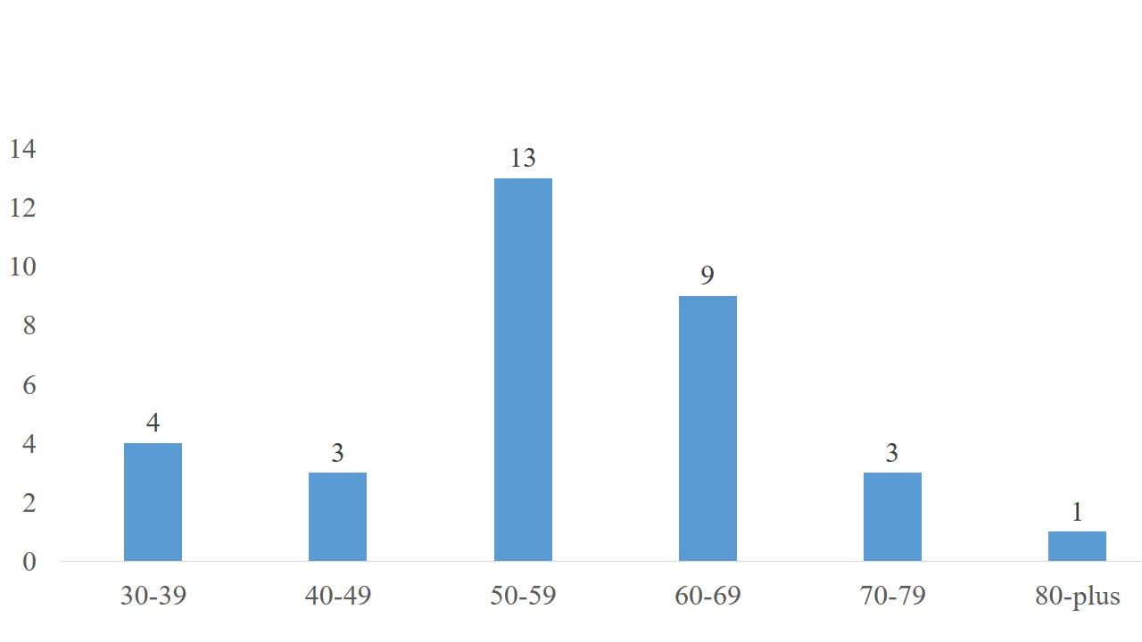

Figure 1 : age (years) distribution of infections
The concept of alcohol and tobacco poisoning was found in 44 patients; of these, 12 had post-operative infection (p = 0.593). Three patients were hypertensive and all had an infection. The 3 HIV-positive patients and the 3 diabetics in the series had no infection. Preoperative radio-chemotherapy had been a history of therapy in a patient who had not developed a post-operative infection.
With regard to the distribution according to the site of the cancer, the infection complicated laryngeal surgery in 15 cases, oral surgery in 10 cases, salivary gland surgery in 6 cases as well as facial surgery in 2 cases ; p = 0.154. The distribution by cancer site is summarized in Figure 2.
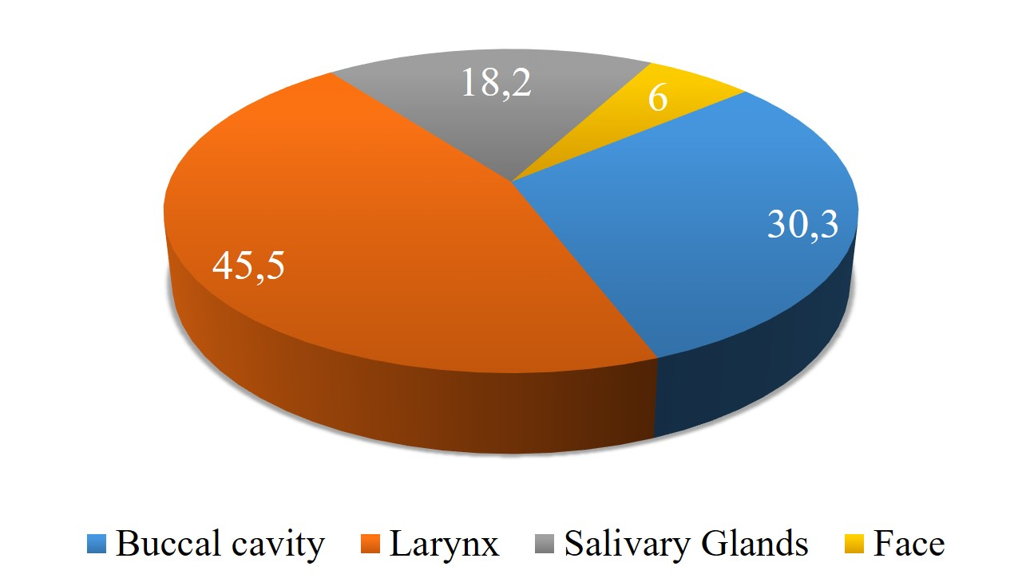
Figure 2 : Distribution by cancer site

Depending on the TNM stage, 18.9% of the infection cases concerned the T2 stage, 22.5% (T3), 51.1% (T4); p = 0.048.
Forty-four percent (44%) of patients with a simple type of surgical closure had an infection compared to 17.9% for types of flap closure (Figure 3); p = 0.001.

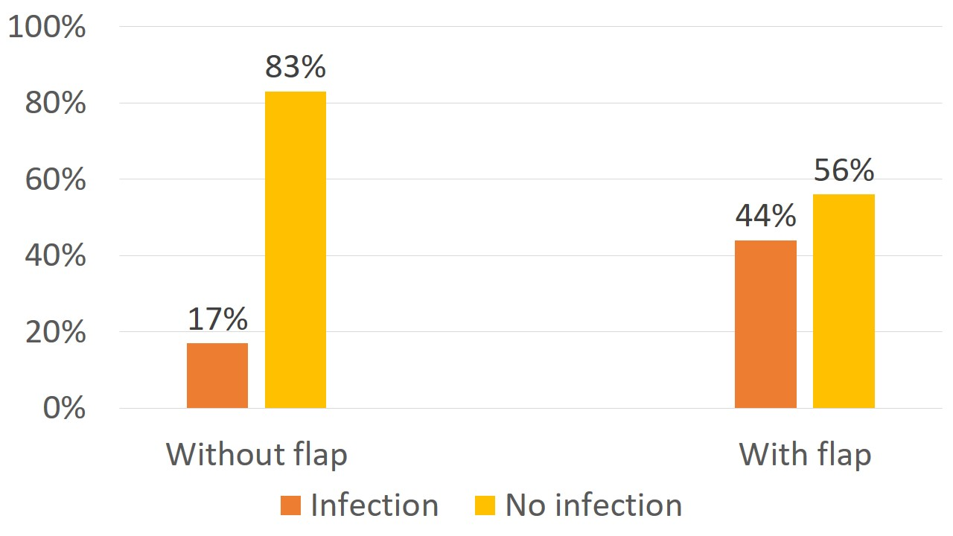
Figure 3 : Distribution according to the type of closure of the operating wound

Of the 7 patients transfused in per or post operative 4 had developed an infection, that is 57.1% of the transfused patients.
Depending on the contamination class, 6/20 class 1 patients had developed a post-operative infection as well as the 27/118 class 2 patients; (p = 0.346).
The incidence of infection in patients with a tracheostomy tube was 27.7% compared to 20.5% in the others (p = 0.828).
On the bacteriological level, the antibiogram results were obtained for 28 patients; the remaining 5 patients were not removed. The most frequently found germs were Pseudomonas aeruginosa (16 cases), Enterobacter spp (4 cases), Staphylococcus aureus (3 cases) (Figure 4). Eight (8) cases of co-infection had been identified.

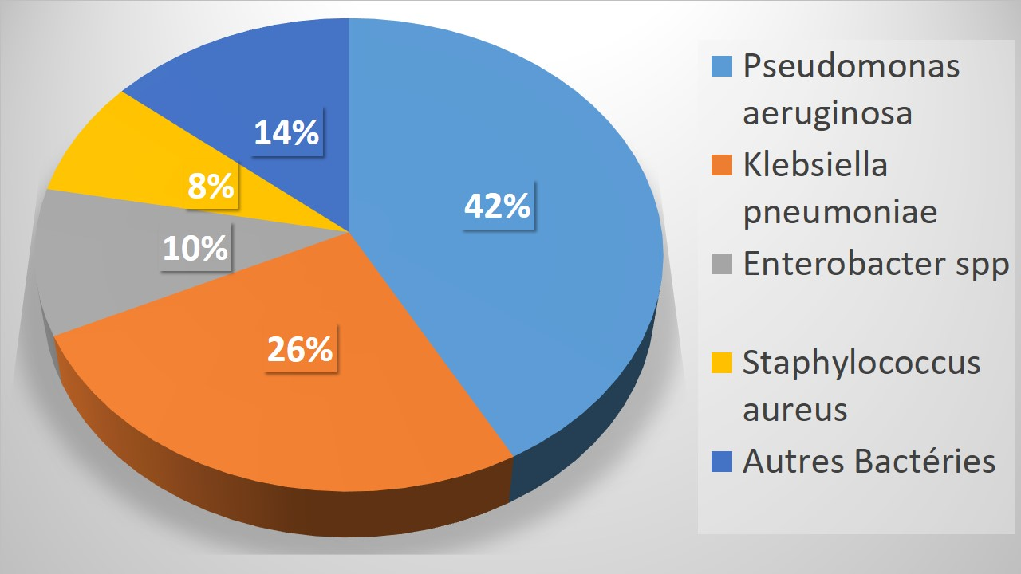
Figure 4: Different types of germs isolated
After adaptation to the antibiogram, the most used molecule was ciprofloxacin (21 cases). Figure 5 summarizes the antibiotics suitable for the antibiogram used.
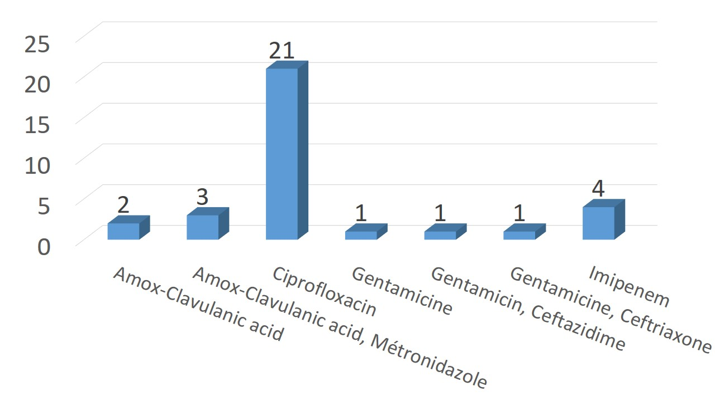
Figure 5: Different types of antibiotics suitable for the antibiogram
DISCUSSION
As in the majority of retrospective studies, selection bias is noted in our study due to incomplete records. Other situations are also limitations to our study. In our structure, the bacteriological laboratory is not open on weekends, some bacteriological samples have been delayed until the following week. We also point out that the bacteriological examination may not find germs when the patient has already received antibiotic prophylaxis.
From our observations, it seems that the occurrence of postoperative infections is correlated with the use of flaps in the closure of operative wounds.
Flap repair gave more infections than simple closure repair in our study (p = 0.001) as in the study by Bourget [4] and Suh [5]. Other authors have also had the same observations [6-8].
This higher incidence of OSI in patients with flap closure is the product of several risk factors for infection. In fact, tumors requiring flap closure are locally more advanced (high T) and the duration of the surgical procedure aimed at removing them is higher. As a result, the tissues are exposed to the environment of the operating room for a longer time, but also to saliva if it is a tumor of the oral cavity, the oropharynx and the pharyngolarynx. Several authors support this hypothesis and report that cases of OSI would be 1.5 to 4 times more frequent in case of flap closure [8-10]. It should also be noted that these tumors are very hemorrhagic; hence the frequency of transfusions constituting an additional risk factor for OSI because leading to a state of transient immunosuppression [11, 12].
Statistical analysis of the other parameters studied in our study did not establish a link with the occurrence of OSI, although their presence influences it. In contrast, many authors have reported correlations in their series.
Events prior to surgery
These are alcohol-tobacco exposure and radio-chemotherapy. The latter have long been considered as being able to favor the occurrence of a postoperative infection.
Lotfi's study [8] had found a relationship between the occurrence of infection and alcohol consumption. Indeed excessive consumption of alcohol increases post-operative stress and leads to a decrease in tissue perfusion. Likewise, tobacco decreases the production of collagen and tissue oxygenation [13].
In our study we had only one case of preoperative radio-chemotherapy; this patient subsequently developed an OSI. Thus, our data were not sufficient to establish a link between preoperative radio-chemotherapy and the occurrence of postoperative infection. However, several studies such as that of Dassonville [14] and Benatar [15] have reported a correlation between the occurrence of postoperative infection in ENT oncology and preoperative radio-chemotherapy. This trend in the development of OSI is linked to the fact that radio-chemotherapy weakens the immune system.
The size of the tumor
In our series, the tumor was classified as T4 in more than half of the post-operative infection cases. The same is true of the studies of Ogihara [18] and Belusic-Gobic [19]. The increase of OSI in this scenario would be linked to the need for a large incision aimed at better exposing the tumor [20].
In addition, advanced tumors have a longer duration of evolution; this increases the risk of secondary infection
The contamination class
Lee's study [16] showed that clean contaminated surgery (Altemeier class 2) increased the risk of post op infection. Indeed, it is a surgery with opening of the pharynx causing an invasion of the operating wound by the germs of the ENT sphere.
Tracheostomy
Regarding the tracheostomy, half of our infected patients were cannula carriers even if we did not find any significant difference between the 2 groups.
Lee had shown that tracheostomy significantly increased the risk of developing post-operative infections [16]. Indeed, the communication of the respiratory tract with the external environment is a situation favoring bacterial colonization [17]. In addition, the secretions which accumulate at the level of the cannula favor the occurrence of infections.
Germs found
Pseudomonas aeruginosa was the germ most involved in SSIs in our series (n = 16), followed by Klebsiella pneumoniae.
Breda [23] made the same observations with Pseudomonas, Escherichia coli and Klebsiella as the main germs.
In patients with ENT tumors, the bacterial flora is greatly modified. The most common germs being Gram negative including Pseudomonas and enterobacteria [1]. Liu had found a higher frequency of Pseudomonas (69%), followed by enterobacteria and enterococcus [6].
Antibiotic prophylaxis
Becker and Parell [21] found that antibiotic prophylaxis reduced the occurrence of postoperative infection. In our work, all patients received treatment with amoxicillin-clavulanic acid; despite this, we found a 29.3% frequency of antibiotic prophylaxis failure. Thus, in our context, the notion of bacterial resistance to the combination of amoxicillin and clavulanic acid cannot be ruled out [22]. Preoperative antibiotic prophylaxis restricted to the first 24 hours seems sufficient to prevent OSI [1].
CONCLUSION
The occurrence of post-operative infection was strongly attributable to the use of a closure flap, hence the need to observe strict hygiene for these patients who should benefit from it.
In view of our observations, the role of antibiotic prophylaxis using the combination of amoxicillin and clavulanic acid seems to be minimal. Their use should be prohibited for the benefit of patients' financial savings.
The place of ciprofloxacin in antibiotic prophylaxis should be the subject of a randomized study.
Authors contribution
All authors were involved either in patient care or in the correction of the manuscript.
Statement of grant
None
Conflict of interest
None
REFERENCES
- Garnier M, Blayau C, Fulgencio J P, et al. Conduite rationnelle de l’antibioprophylaxie : revue systématique en chirurgie carcinologique ORL. Annales Françaises d’Anesthésie et de Réanimation. 2013 ; 32 : 315–324
- Brun B. Les infections nosocomiales: bilan et perspectives. rev.med/sciences. 2000 ; 16 : 89-102
- Altemeier WB, Buke J, Pruitt B, Sandusky W. Manual of control of infection in surgical patients, 2nd ed, Philadelphia: Lippincott JB; 1984.
- Bourget A, Chang JT, Wu DB, Chang CJ, Wei FC. Free flap reconstruction in the head and neck region following radiotherapy: a cohort study identifying negative outcome predictors. Plast Reconstr Surg. 2011; 127: 1901–08.
- Suh JK, Sercarz JA, Abemayor E. Analysis of outcome and complications in 400 cases of microvascular head and neck reconstruction. Arch Otolaryngol Head Neck Surg. 2004; 130: 962–66.
- Liu SA, Tung KC, Shiao JY, Chiu YT. Preliminary report of associated factors in wound infection after major head and neck neoplasm operations–does the duration of prophylactic antibiotic matter. J Laryngol Otol. 2008; 122:403–8.
- Brown BM, Johnson JT, Wagner RL. Etiologic factors in head and neck wound infections. Laryngoscope 1987 ; 97:587–90.
- Lotfi CJ, Cavalcanti Rde C, Costa e Silva, et al. Risk factors for surgical-site infections in head and neck cancer surgery. Otolaryngol Head Neck Surg. 2008;138:74–80.
- Johnson JT, Myers EN, Thearle PB, et al. Antimicrobial prophylaxis for contaminated head and neck surgery. Laryngoscope. 1984;94:46–51.
- Weber RS, Raad I, Frankenthaler R, et al. Ampicillin-sulbactam vs clindamycin in head and neck oncologic surgery. The need for Gram-negative coverage. Arch Otolaryngol Head Neck Surg. 1992;118:1159–63
- Nielsen HJ, Reimert CM, Pedersen AN, et al. Time-dependent, spontaneous release of white cell- and platelet-derived bioactive substances from stored human blood. Transfusion. 1996;36:960–5.
- Frewin DB, Jonsson JR, Head RJ, et al. Histamine levels in stored human blood. Transfusion. 1984 ; 24:502–4.
- Fraioli R, Johnson JT. Prevention and treatment of postsurgical head and neck infections. Curr Infect Dis Rep. 2004; 6: 172-180
- Dassonville O, Poissonnet G, Chamorey E. Head and neck reconstruction with free flaps: a report on 213 cases. Eur Arch Otorhinolaryngol. 2008; 265: 85–95.
- Benatar MJ, Dassonville O, Chamorey E. Impact of preoperative radiotherapy on head and neck free flap reconstruction: a report on 429 cases. J Plast Reconstr Aesthet Surg. 2013; 66: 478–82.
- Lee DH, Kim SY, Nam SY, Choi SH, et al. Risk factors of surgical site infection in patients undergoing major oncological surgery for head and neck cancer. Oral Oncology. 2011 ; 47 :528–531
- Cole RR, Robbins KT, Cohen JI, Wolf PF. A predictive model for wound sepsis in oncologic surgery of the head and neck. Otolaryngol Head Neck Surg. 1987;96(2):165–71.
- Ogihara H, Takeuchi K, Majima Y. Risk factors of postoperative infection in head and neck surgery. Auris Nasus Larynx. 2009; 36: 457-460
- Belusic-Gobic M. Multivariate analysis of risk factors for postoperative wound infection following oral and oropharyngeal cancer surgery. Journal of Cranio-Maxillo-Facial Surgery. 2018; 46(1) : 135-141.
- Karakida K, Aoki T, Ota Y. Analysis of risk factors for surgical-site infections in 276 oral cancer surgeries with microvascular free-flap reconstructions at a single university hospital. J Infect Chemother. 2010; 16: 334–39.
- Becker GD, Parell GJ. Cefazolin prophylaxis in head and neck cancer surgery. Ann Otol Rhinol Laryngol. 1979; 88: 183–86.
- H. Rodriguez-Villalobos, M.-J. Struelens. Résistance bactérienne par β-lactamases à spectre étendu : implications pour le réanimateur. Réanimation. 2006 ; 15(3) : 205-213.
- Sá Breda M. Infectious complications in head and neck surgery: Porto Oncology Centre retrospective analysis. Acta Otorrinolaringologica (English Edition). 2019 ; 70(1) :6-15.

