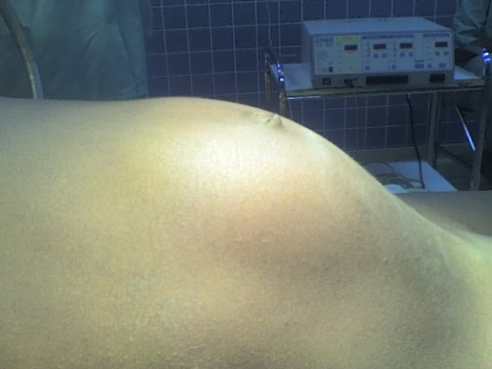

Figure 1. Right lateral aspect of the abdominal mass in the inspection. The patient is lying on the operative table in a dorsal decubitus position.

