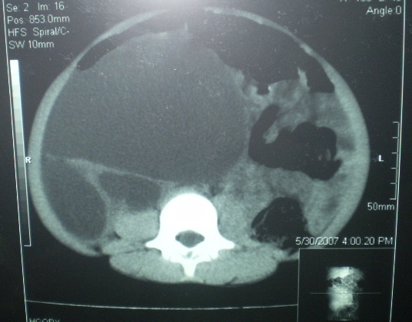

Figure 2. CT-scan transversal cross section through the body of the 3rd lumbar vertebra before injection of the contrast product.

