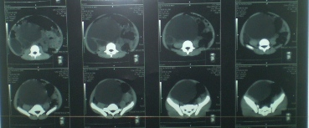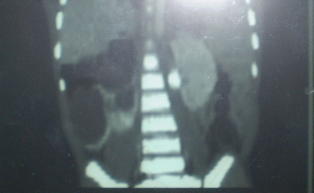
Figure 3. Abdominal CT-scan sections before the contrast product showing the extend of the mass. Top: transversal cross sections from L3 to S2. Bottom: coronal reconstruction showing the right localization and sacculations of the cyst.

