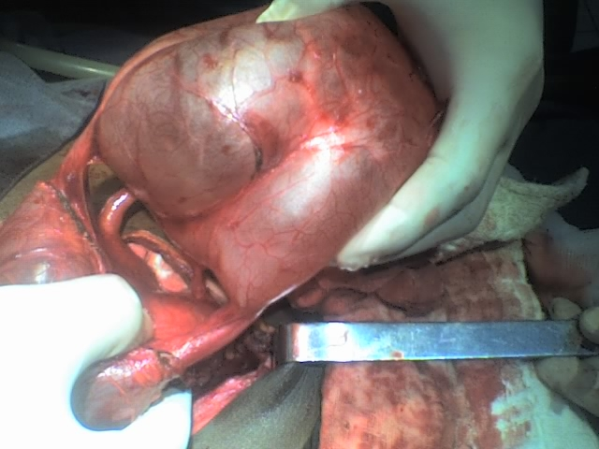
Figure 4. Operative finding of quadruplicated ureter and the cystic urinary proximal mass due to the malformation.
The mass is sectioned from its proximal attach, the other two ureters are seen in the second plan.

