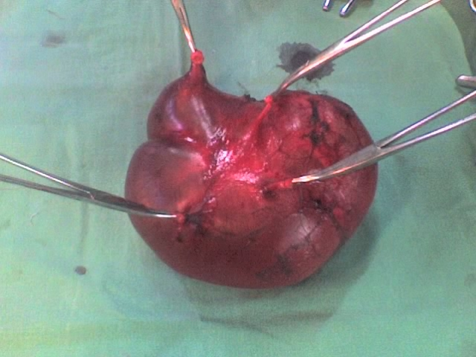
Figure 6. Piece of resection of the dilated proximal ureteral portion showing the four calices which are now transformed in a single pelvis: inferior view of the whole resected mass.

