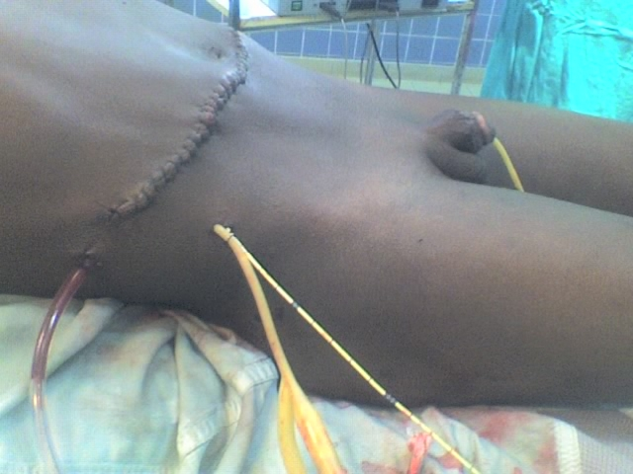
Figure 7. The abdomen at the end of the surgery showing the 4 catheters of retro peritoneum, kidney, ureter and urethra.
Nephrostomy is the upper Foley catheter close to the ureteral one. The upper suction catheter is from the perirenal space.

