Heterotopic pregnancy as revealed by a delayed and stopped left ampulla pregnancy: a case study at the Regional Hospital of Ngaoundere-Cameroon
NGAROUA*¹, NEOSSI N. M², MBO A.J.², ELOUNDOU N. J.³
1. Service de Chirurgie, Hôpital Régional de Ngaoundéré
2.Service de Radiologie, Hôpital Régional de Ngaoundéré3,
3. Département de Chirurgie, FMSB, Université de Yaoundé I

3,4,5 Département de Chirurgie, FMSB, Université de Yaoundé I

Abstract
Introduction
Heterotopic pregnancy or simultaneous pregnancy is defined as the association of intra-uterine pregnancy and extra-uterine pregnancy in the same patient. Formerly rare, the frequency of this simultaneous pregnancy has steadily increased with the appearance of medically assisted reproduction, or ovulation induction technics. The diagnosis is difficult, and occurs very late.
Objectives
The main objective of this study was to detect a case study of an HP in a 32 years old patient admitted to the hospital for a delayed abdominal pregnancy. After observations, a literature review was searched in order to better understand the epidemiological aspects, diagnosis and therapeutic of this unusual and cheated clinical pathology.
Observations
The patient had no trouble in the stomach, nor associated metrorragy. In her preceedings, she was nullipara, without abortion notion. Examination at the entrance showed a general normal state. The stomach was distended without peritoneal irritation signs, nor occlusive syndrome.

Results
The ultrasound revealed a delayed abdominal pregnancy of 26 weeks, and no sign of IUP. A scheduled laporotomy indicated a late and undisrupted left ampulla pregnancy with a fetal deformation, and an inserted placenta on the left annex of the gestated uterus. A left annexectomy was carried out with little manipulations of the uterus. The controlateral annex had no particularity. A tocolysis was realized during the first week post surgeon. Unfortunately, the operation led to a spontaneous abortion two weeks later.
Conclusion
If heterotopic pregnancy is rarely encountered in our country, its incidence is increasing in developed countries due to development of medically assisted reproduction. Our observations illustrate the diagnosis difficulties and the complexity of precautions taken in particular for intra-uterine pregnancy. A following up of pregnant women should be taken into consideration to guaranty a complete pregnancy without associated risks.

Key words: Heterotopic pregnancy, intra-uterine pregnancy, extra-uterine pregnancy, left annexectomy, etiopathogeny.

Résumé
Introduction
Une grossesse hétérotopique ou encore grossesse combinée se définit par une association d’une grossesse intra-utérine et d’une grossesse extra-utérine chez une même patiente. Autrefois fort rare, la fréquence de cette association ne cesse de croître depuis l’apparition de l’aide médicale à la procréation et des techniques d’induction de l’ovulation. Le diagnostic est difficile et tardif.
Objectifs
L’objectif principal de ce travail est de détecter un cas de un cas de grossesse hétérotopique chez une patiente de 32 ans admise dans le service pour grossesse abdominale arrêtée. A travers notre observation, une revue de la littérature a été faite pour mieux cerner les aspects épidémiologiques, diagnostic et thérapeutique de cette entité clinique rare et trompeuse.
Observations
Le patient n’avait ni trouble digestif ni métrorragie associée. Dans ses antécédents on note qu’elle est nullipare, sans notion d’avortement. Les cycles antérieurs étaient sans anomalies. L’examen à l’entrée notait un bon état général. L’abdomen était distendu sans signe d’irritation péritonéal ni du syndrome occlusif.
Résultats
L’échographie révélait une grossesse abdominale arrêtée de 26 semaines tout en méconnaissant une grossesse intra-utérine. Une laparotomie programmée avait permis de découvrir une grossesse ampullaire gauche tardive non rompu avec déformation du fœtus et insertion du placenta sur l’annexe gauche l’utérus était gravide. Une anexectomie gauche était réalisée avec une manipulation minime de l’utérus. L’annexe controlatérale était sans particularité. Une tocolyse était réalisé pendant la première semaine post-opératoire ; cependant les suites opératoires étaient marquées par une fausse couche spontanée dès la deuxième semaine après l’intervention.
Conclusion
Si la grossesse hétérotopique se rencontre rarement dans notre pays, son incidence est en nette progression dans les pays développés en rapport avec le développement de la procréation médicale assistée. Notre observation illustre les difficultés diagnostics et la complexité de sa prise en charge en particulier de la grossesse intra-utérine. Un suivi rapproché des femmes enceintes est de rigueur pour garantir une grossesse à terme sans risque.

Mots clés : Grossesse heterotopique, grossesse intra-ulterine, grossesse extra-ulterine, annexectomie gauche, ectopathogenie.

*Correspondence to
Dr. NGAROUA, Service de Chirurgie, Hôpital Régional de Ngaoundéré BP 45 ;Tel: (237) 99 97 83 51
Email: mdngaroua2007@yahoo.fr

INTRODUCTION
Heterotopic pregnancy (HP) or simultaneous pregnancy (SP) is defined as the association of intra-uterine pregnancy (IUP) and extra-uterine pregnancy (EUP) in the same patient [1]. Formerly rare, the frequency of this SP has steadily increased with the appearance of medically assisted reproduction, or ovulation induction technics [2]. The diagnosis is difficult, and occurs very late [3]. We report a case study of an HP in a 32 years old patient admitted to the hospital for a delayed abdominal pregnancy. After observations, a literature review was searched in order to better understand the epidemiological aspects, diagnosis and therapeutic of this unusual and cheated clinical pathology.

Case report
Madam AOS, 32 years old was admitted to the hospital for a delayed abdominal mass syndrome. She has no trouble in the stomach, nor associated metrorragy. In her preceedings, she was nullipara, without abortion notion.

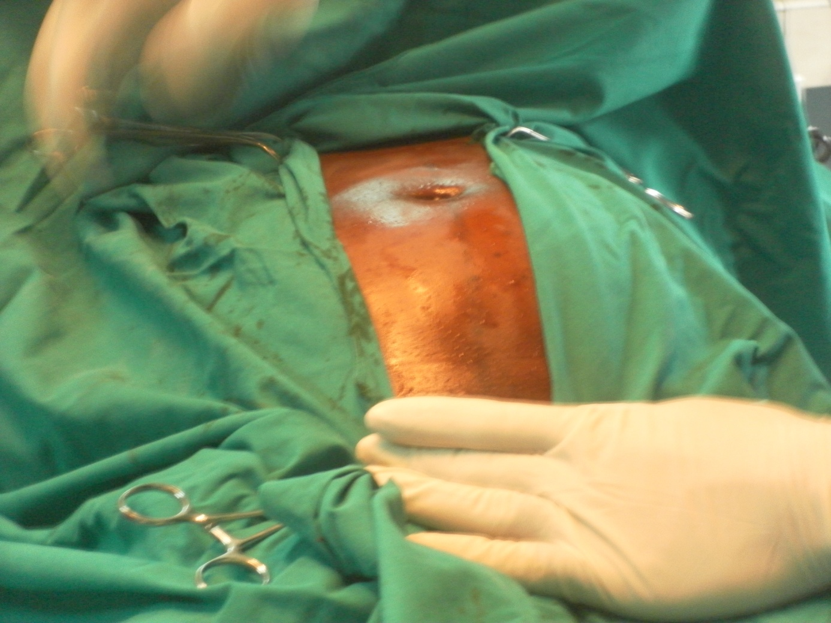 A 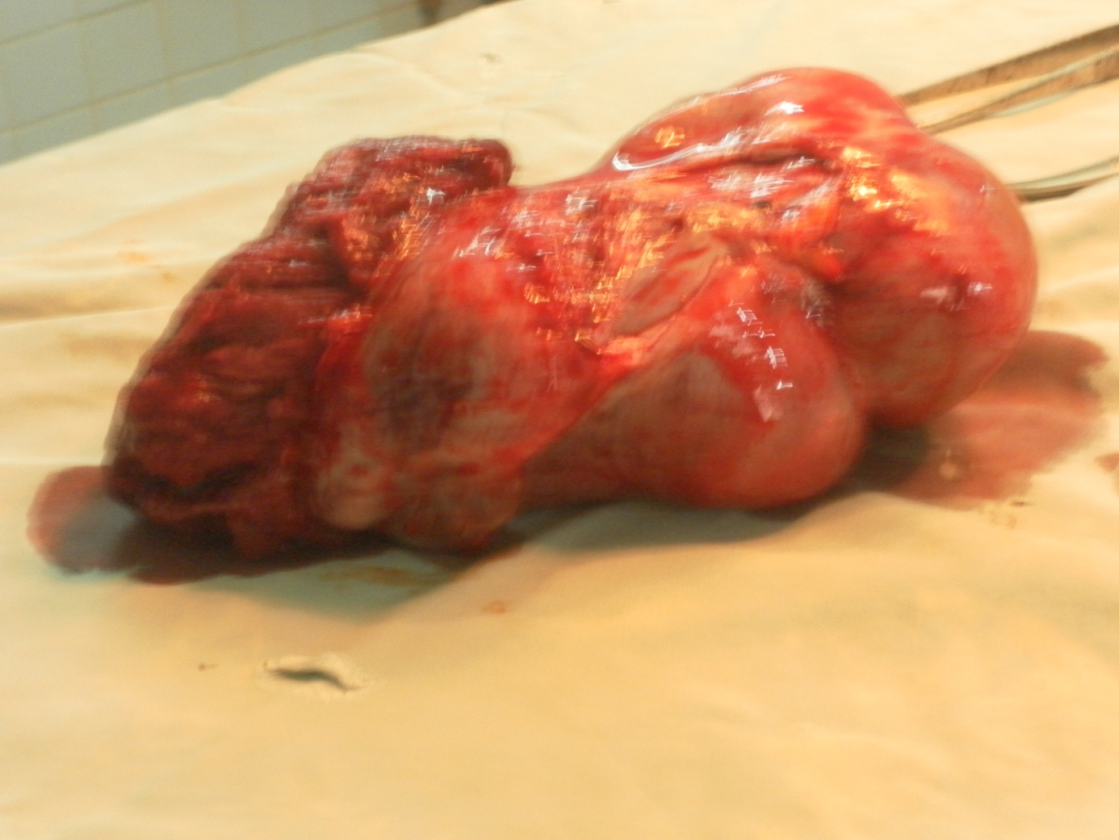B

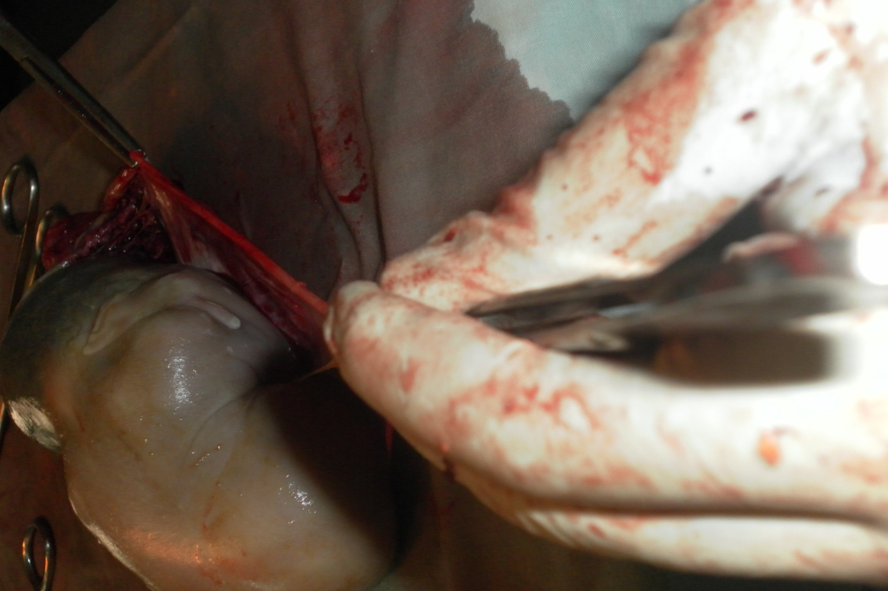 C 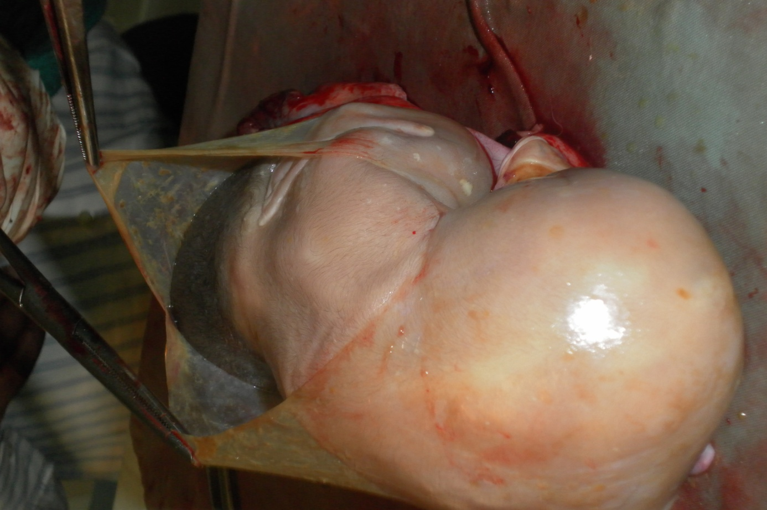D
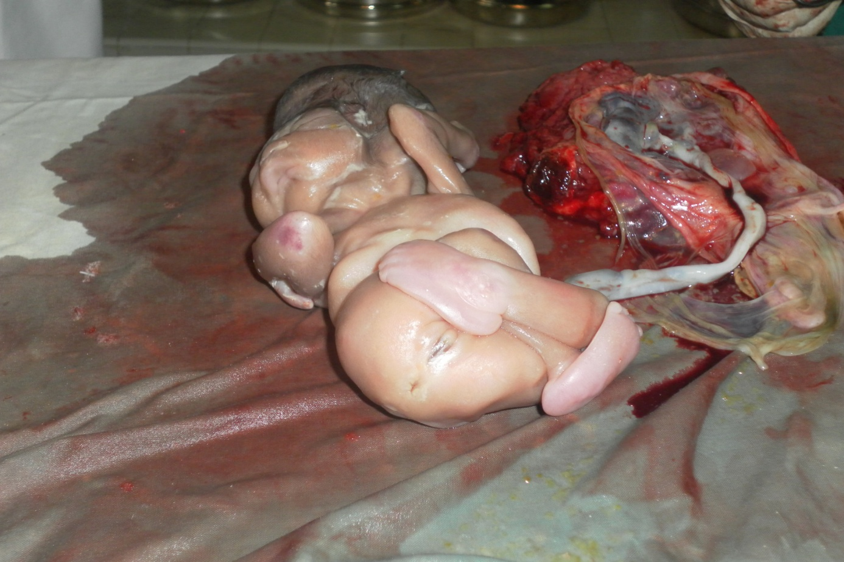 E 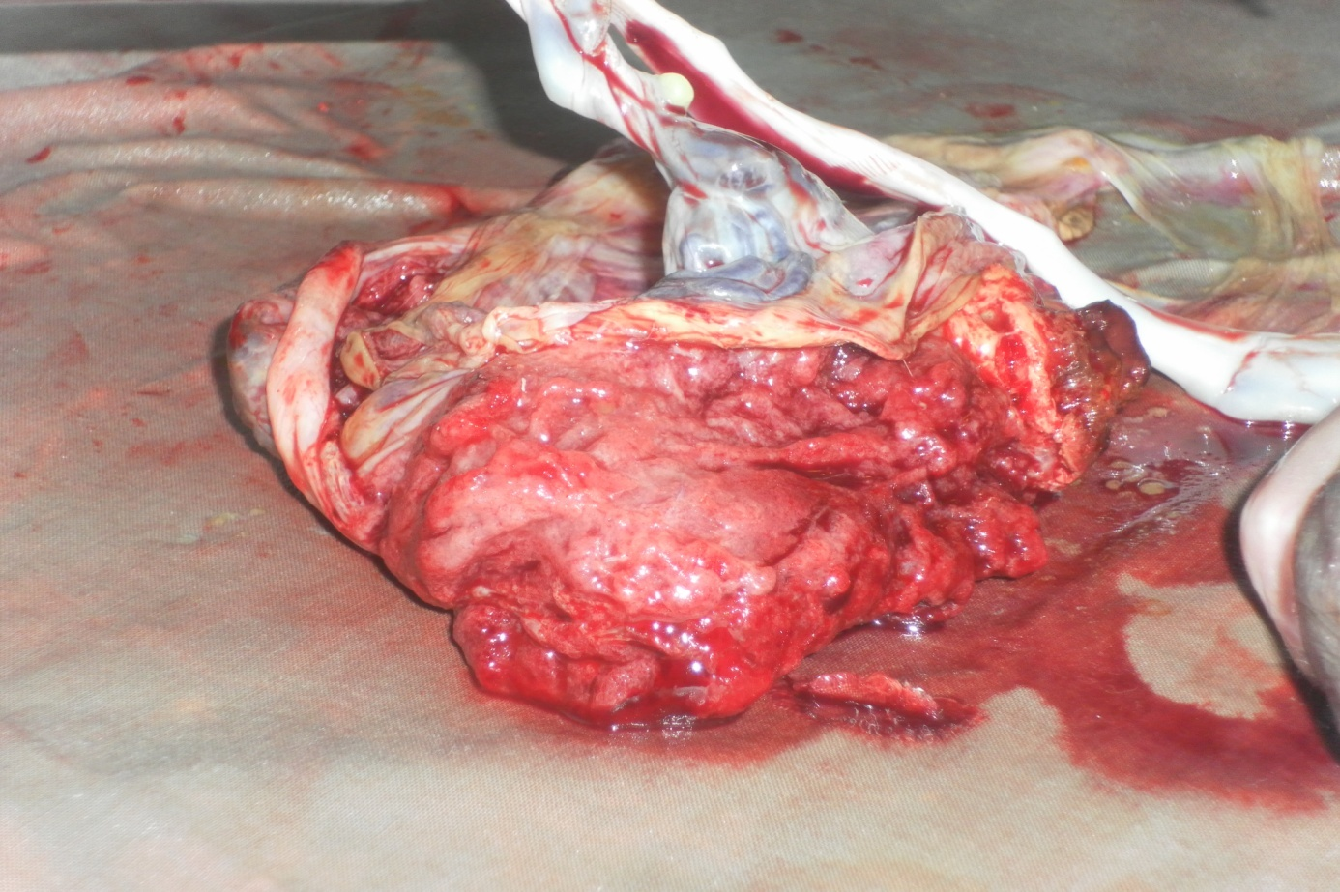F
Figure 1. Steps in the surgeon process: Abdominal distention (A); Mass (B); tubal membrane (C); Amniotic membrane (D); Deformed fetus (E); placenta (F)

Examination at the entrance showed a general normal state. The stomach was distended without peritoneal irritation signs, nor occlusive syndrome. The ultrasound revealed a delayed abdominal pregnancy of 26 weeks, and no sign of IUP. A scheduled laporotomy indicated a late and undisrupted left ampulla pregnancy with a fetal deformation, and an inserted placenta on the left annex of the gestated uterus. A left annexectomy was carried out with little manipulations of the uterus. The controlateral annex had no particularity. A tocolysis was realized during the first week post surgeon. Unfortunately, the operation led to a spontaneous abortion two weeks later.

DISCUSSION
The association of extra and intra-uterine pregnancy is a particular form of twin pregnancy, also called ditopic or heterotopic, that was first described in 1708 by Duvernet [4]. It is an unusual pathology, which frequency is located at between 1/10000 and 1/30000 within the population in general [2]. Presently, this frequency is raising up in developing countries due to increased rate of acute salpingitis linked to untreated sexually transmitted infections and septic abortion on one hand, and on the other, to medically assisted treatment such as induction of ovulation and in vitro fecundation in developed countries [6]. To the best of our knowledge, no such a study on the frequency of this pathology has been investigated in the country. In addition, the previous EUP or abortion constitutes other risk factors [7]. Despite the frequent use of ultrasound, the diagnosis difficulties of this pathology are still a reality as confirmed by our observations. The diagnosis is very easy when clinical signs of EUP are early detected: abdominal-pelvian pain in 82.7% of cases and metrorragies in 50% of cases [8]. These signs could therefore, be confused to other pathologies, leading to late diagnosis and treatment. Nevertheless, a transvaginal ultrasound could early allow detection of the pathology in 88.9% of cases, when an intra or extra-uterine egg is revealed [9].
The indications of limited medical treatment are closely related to hemodynamic stability [10]. However, operations have been indicated as standard treatment in recent literature [2]. Moreover, if the hemodynamic situation is scarcely due to disruption of the ectopic pregnancy, it is wise to overcome through laporotomy. This operation could not perturb the development of IUP, considering that manipulations of uterine are limited, and that anesthesia takes place for a short time; in addition, the prophylactic tocolysis was not necessary [11]. Despite the pre-surgeon care taken for this IUP, a spontaneous abortion occurred. In contrast, maternal prognosis was similar to that of the simple EUP with a mortality rate lower than 1% [12].

CONCLUSION
If HP is rarely encountered in our country, its incidence is increasing in developed countries due to development of medically assisted reproduction. Our observations illustrate the diagnosis difficulties and the complexity of precautions taken in particular for IUP. A following up of pregnant women should be taken into consideration to guaranty a complete pregnancy without associated risks.

REFERENCES

1. Duvernay GJ: Anatomic production, Joubert, Paris, France, 1781.
2. Diallo D; Aubard Y; Piver P; Baudet JH: Heterotopic pregnancy: based on 5 cases study and literature review. Journal of Gynecology Obstetric and Biology of Reproduction 2000, 29: 131-41.
3. Montilla F; Amar P; Boyer S; Karoubi R; Diquelou IY: Heterotopic pregnancy: based on one case in a rare clinical table. Journal of Gynecology Obstetric and Biology of Reproduction 2007, 36(3): 302-5.
4. Engongah-Beka T; Meyer JF; Ozouaki F; Sima-Ole B: Association of disrupted intra-uterine and extra-uterine pregnancy: based on 2 cases study with different evolutions and literature review. Médecine d’Afrique Noire 1997, 44: 8-9.
5. Sepou A; Yanza MC; Nguembi E; Goddot M; Ngbale R; Kouabosso A: Epidemiologic and clinical aspects of 116 extra-uterine pregnancy cases at the communal hospital of Bangui. Médecine d’Afrique Noire 2003, 50 (10): 405-12.
6. Fivnat questionnaires: Risk factors of Extra-uterine pregnancy during medically assisted reproduction. Contraception fertility and sexuality 1993, 21(5): 358-61.
7. Tancer ML; Delke I; Veridiano NP: A fifteen year experience with ectopic pregnancy. Surgery and Gynecology Obstetric 1981, 152: 179-82.
8. Tal J; Haddad S; Gordon N; Timor-Tritsu I: Heterotopic pregnancy after ovulation induction and assisted reproductive technologies: a literature review from 1971 to 1993. Fertility and Sterility 1996, 66: 1-12.
9. Guirguis RR: Simultaneous intra-uterine and ectopic pregnancies following in vitro fertilization and gamete intrafallopian transfer. A review of nine cases. Human Reproduction 1990, 5: 484-6.
10. Baker VL; Givens CR; Cadieux MC: Transvaginal reduction of an interstitiel heterotopic pregnancy with preservation of the intra uterine gestation. American Journal of Obstetric Gynecology 1997, 176: 1384-5.
11. Molloy D; Deambrosis W; Keeping D; Multiple sited (heterotopic) pregnancy after in vitro fertilization and gamete intra fallopian transfer. Fertility and Sterility 1990, 53: 1068.
12. Dicker D; Goldman G; Feldberg D; Ashchkenazi J; Goldman J: Heterotopic pregnancy after IVF-ET: report of a case and a review of the literature. Human Reproduction 1989, 4: 335.

