Photo 1 : increased in volume belly
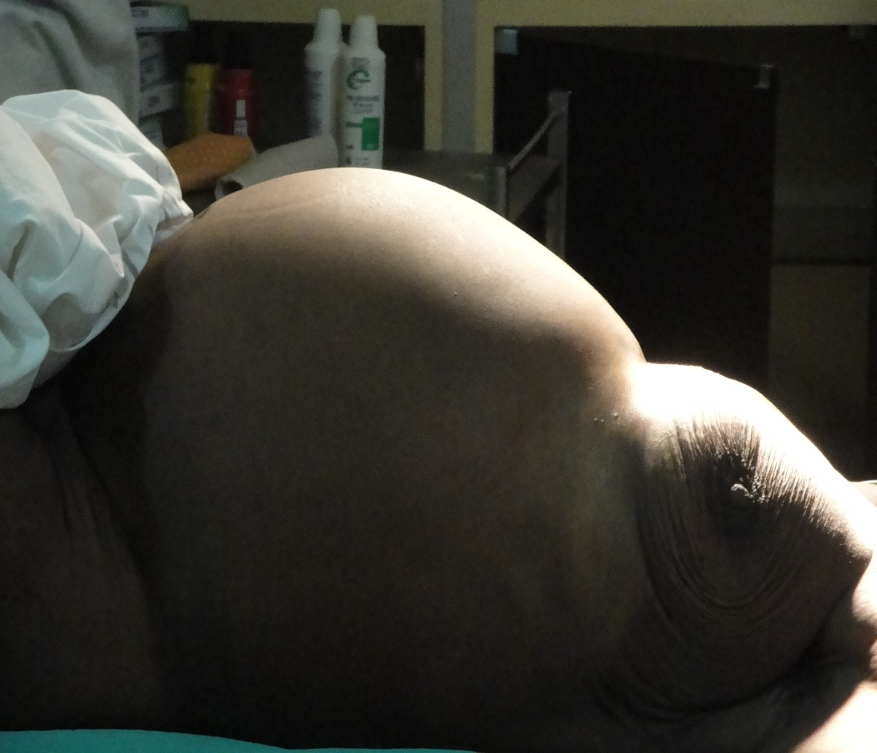

Photo 2 : vesicles in nest of bee in the echography
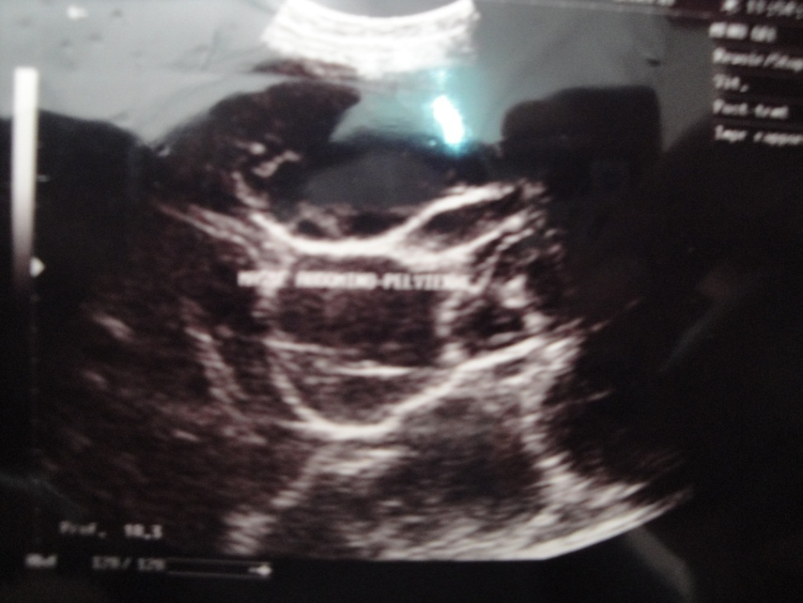

Photo 3 : membrane in double outline in the echography
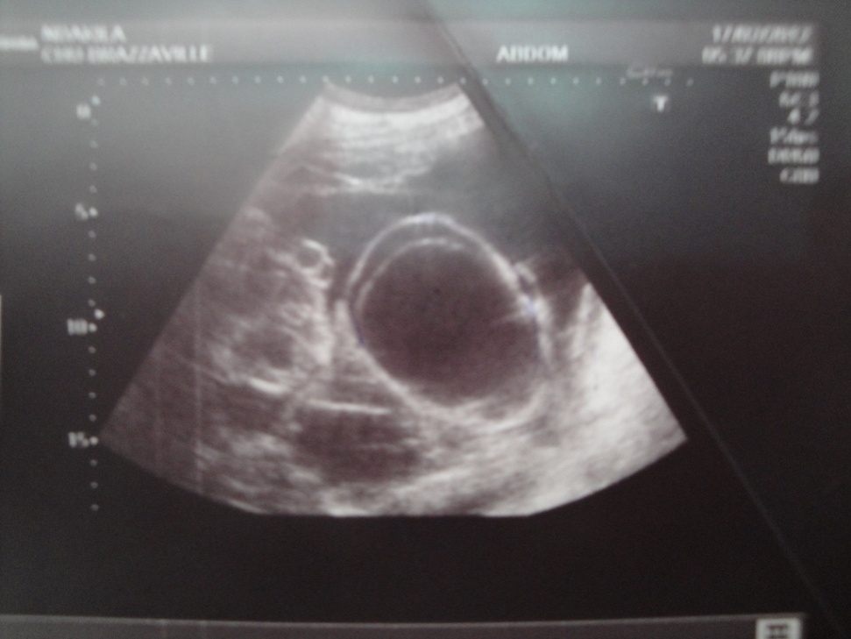

Photo 4 : cyst of the peritoneum in the scanner
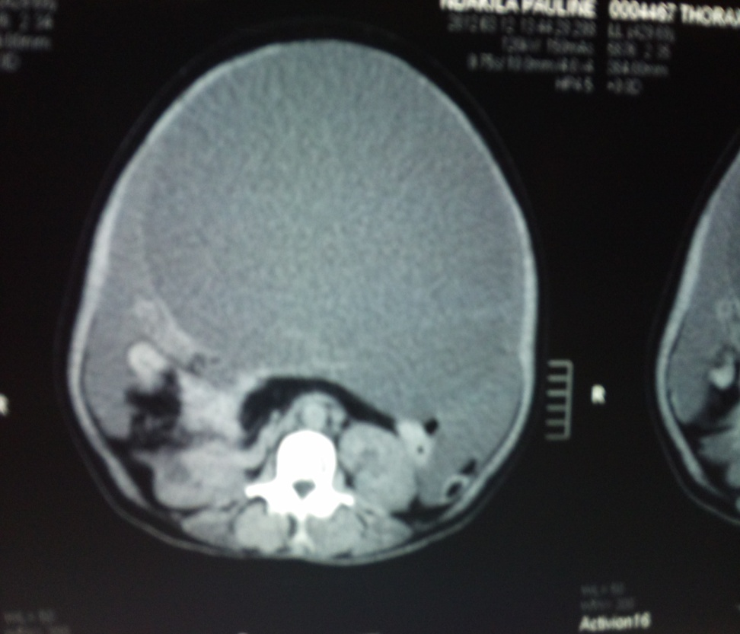

Photo 5 : multicompartmentalized aspect of the cyst in the scanner
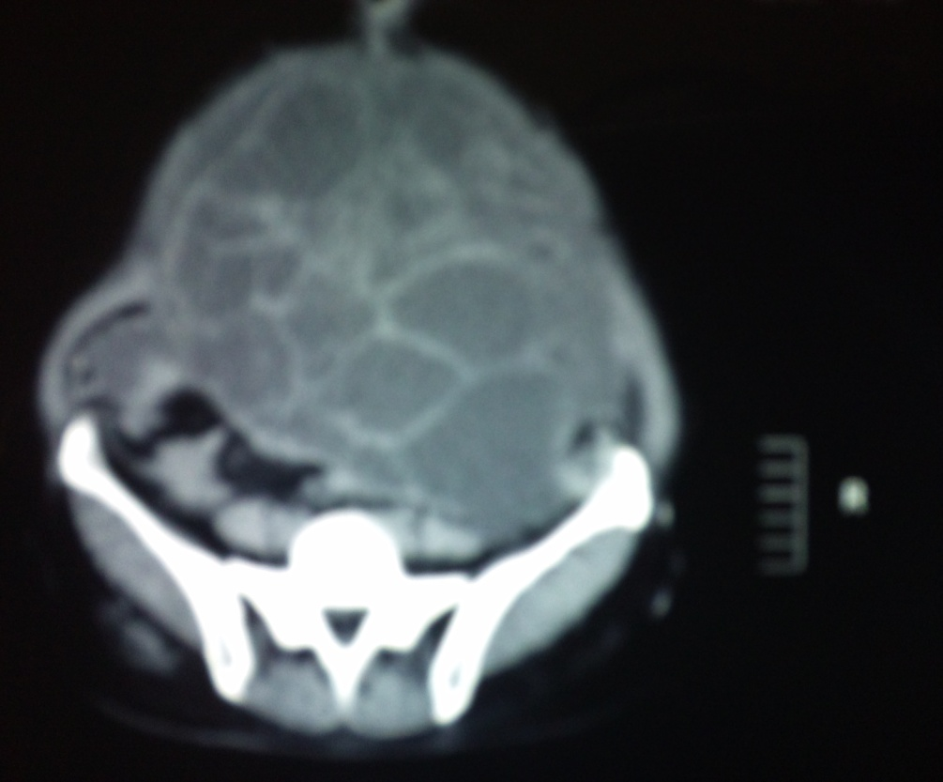

Photo 6 : contents of the cyst replaced by the hypertonic salty serum
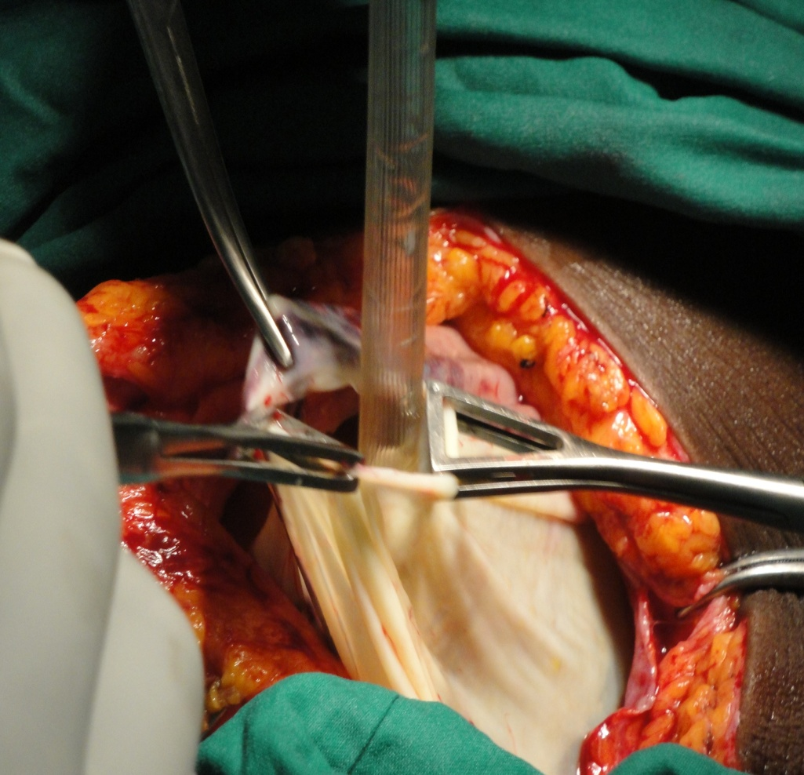

Photo 7 : small-sized vesicles in the cyst
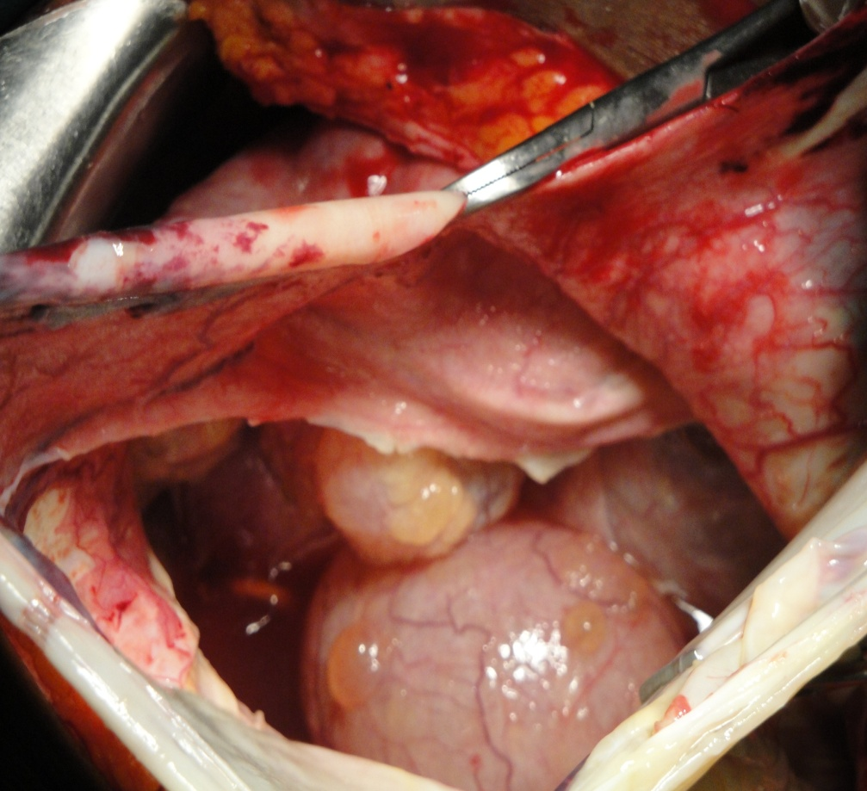

Photo 8 : ablation of all the cyst
